PAWNSHOPS TO TEACH PERCENT AND PERCENT TO TEACH PAWNSHOPS
Laurie H. Rubel Vivian Lim
City University of New York University of Pennsylvania
LRubel@brooklyn.cuny.edu Viv.Lim@gmail.com
This paper focuses on student learning in the context of a curricular module on pawnshops piloted with 15 students in an urban high school. The paper describes pedagogical frameworks guiding the development of the module and summarizes key features of its curriculum. Analysis focuses on student growth with respect to mathematical understanding of percent and opinions about pawnshops. Findings include student adoption of ratio strategies indicative of conceptual understanding of percent, and development of critical opinions about pawnshops as a lending system.

Keywords: Equity and Diversity
Introduction
Percent is a concept fundamental to the middle school mathematics curriculum. The Common Core State Standards indicate that by 8th grade, students should be able to solve multistep percent problems and apply proficiency with percents to any array of marketplace applications. In addition to being a focal point of middle grades mathematics, the concept of percent undergirds a variety of topics in secondary school mathematics, like scaling, probability, statistics, and modeling.
High school students are known to have difficulties with problem-solving related to percent (Lembke & Reys, 1994; Moss & Case, 1999; Parker & Leinhardt, 1995). Common errors include ignoring the percent sign; difficulties translating between decimals, fractions and percents; and confusion about multiplicative and additive relationships (e.g., Moss & Case, 1999; Parker & Leinhardt, 1995). Finding a given percent of a specific amount is considered the most straightforward for students; however, even at age 17, most students have difficulty with, for instance, finding 4% of 75 (Parker & Leinhardt, 1995).
Percent is prominent across an array of common marketplace transactions (Parker & Leinhardt, 1995). Banking transactions routinely communicate percents, which is essential for any consumer. Beyond its importance in terms of functional literacy for borrowers, percent is necessary for critical literacy (Apple, 1992), enabling citizens to evaluate quantitative information or analyze quantitative relationships. For example, percent figures prominently and broadly as a mathematical tool in teaching mathematics for social justice (e.g., Gutstein, 2005).
Despite its ubiquity in the marketplace, adults are known to have difficulty with percents. In an investigation of adult learners, while most knew that 100% represents the whole and 50% means half, their understanding of 25% was limited; fewer than a third of the adults could find the sale price of an $80 coat on a 25% off sale (Ginsburg, Gal, & Schuh, 1995). Pre-service teachers were successful at answering a multi-step word problem involving percents but had difficulty explaining why particular operations made sense in the task’s solution (Lo & Ko, 2013).
An explanation for difficulty with percent tasks is that it has traditionally been taught strictly using procedural methods. Even though students with pictorial representations of percent are known to be more successful at problem-solving on percent tasks (Lembke & Reys, 1994), classroom instruction is traditionally unaccompanied by mathematical representations that can support conceptual understanding. Representations that can link procedures for solving percent problems to conceptual understanding of percent are area models (e.g., Haubner, 1992), halving or doubling models (e.g., Moss & Case, 1999), 100-board models (e.g., Wiebe, 1986) dual-scale number lines (e.g., Dole, 2000), or ratio tables (e.g., Middleton & Van den Heuvel-Panhuizen, 1995).
This paper explores the teaching and learning of percent within the context of a larger project. The larger project adopts perspectives that integrate culturally relevant pedagogy (Ladson-Billings, 1994) and place-based education (Gruenewald, 2003). The next section briefly describes these frameworks and their correspondence with the project’s curriculum.
Guiding Frameworks
Culturally relevant mathematics pedagogy (CureMap, Rubel & Chu, 2012) is based on Ladson-Billings’ (1994) theory of culturally relevant pedagogy and Gutstein, Lipman, Hernandez, & de los Reyes’ (1997) application of culturally relevant pedagogy to mathematics. CureMap is comprised of teaching mathematics for understanding, centering instruction on students, and providing students with opportunities to think critically about and with mathematics. The three dimensions are interrelated and guide this project’s curriculum design. The larger project, of which this study is a part, takes pawnshops as a familiar phenomenon from the city streetscape and uses it as a guiding theme for the investigation. Mathematics helps students to understand how pawnshops, as local and visible features of a spatial landscape, work.
Teaching for understanding denotes an emphasis on connections between mathematical concepts, procedures, and facts. Classroom instruction that supports teaching for understanding includes rigorous tasks, representational tools, and norms for participation (Carpenter & Lehrer, 1999). Understanding the concept of percent is fundamental to interest and to being able to model a pawnshop loan. To build this understanding, 4% simple interest was organized as a $4 amount for every $100 dollars borrowed in a ratio table (e.g., Middleton & Van den Heuvel-Panhuizen, 1995). Figure 1 shows an example of tables used by the teacher in our project. The table sets up students to conceptualize percent as a ratio and use a ratio table to calculate 4% of various amounts. The table has multiplicative properties (i.e., 4% of 700 is 7 times 4) and additive properties (i.e., 4% of 150 is 4+2). A ratio table can be used to calculate any percent of any quantity but is especially efficient for benchmark values.
Organizing lessons for students to be central participants is an essential component of culturally relevant pedagogy. This module emphasized student participation, particularly emphasizing whole-class discussions to build shared understanding. For example, in one of the beginning lessons, the teacher performed a skit to clarify with students the vocabulary and elements of a pawnshop transaction, and collectively defined the transaction as a collateral loan with a monthly, simple interest rate.
Centering instruction on students can be accomplished in terms of content that connects to students’ lives (e.g., Moll, Amanti, Neff, & Gonzalez, 1992). There is an additional, place-based interpretation of centering: taking a spatially local phenomenon and studying it, at various levels of scale, in students’ local places. Focusing on a specific context, in place, and using mathematics to make sense of that context is an explicit stance that differs from focusing on percent as a theme with applications across multiple contexts.

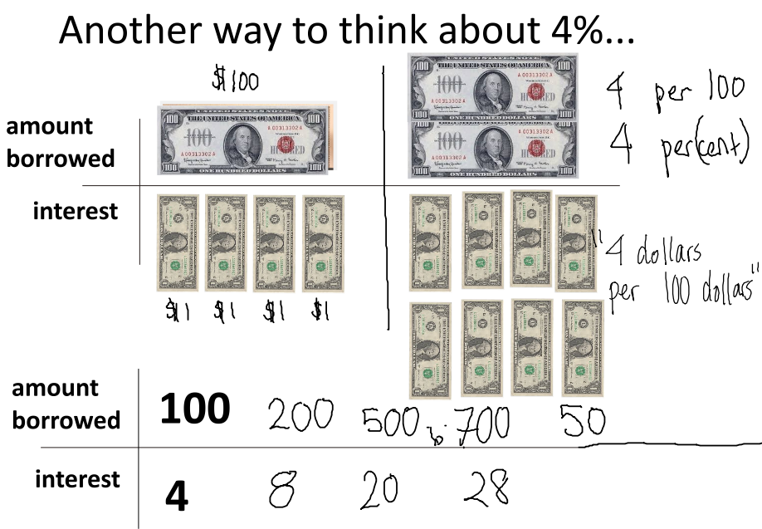
Figure 1: Ratio table used in classroom (11/6/2014)

Real-world contexts with social justice ramifications can motivate mathematics and mathematics enables better understanding of the real-world context (e.g., Gutstein, 2005). In this case, percent is a tool with which to model and compare loans toward exploring critical notions of pawnshop loans as a form of predatory lending or dominant notions of alternative financial institutions (AFIs) as important financial resources for low-income people. Drawing again on notions of local space and place, to investigate spatial patterns in the distribution of financial institutions in the local city, one lesson invited students to consider how to normalize the distribution to analyze which neighborhoods have more AFIs, since numbers of AFIs could be compared to households, land area, or to numbers of banks. Students explored data-rich spatial distributions on interactive, digital maps in the context of understanding the relative cost of different types of loans, set in terms of spatial representations of demographic statistics. Students conducted field research in the school neighborhood to explore the distribution of financial institutions and to interview pedestrians about their experiences as customers of these businesses.
An assumption is that students will develop critical opinions about pawnshops and their role in students’ lives, the local community, and the broader city, and that this development is predicated on an understanding of the concept of percent. This paper explores that assumption by asking two research questions:
- Did students develop conceptual understanding of percent through their participation in this project?
- Did students develop critical thinking about pawnshops through their participation in this project?
Research Context
This module was piloted in a high school in a large Northeastern city in the United States. The school is located in one of the city’s lowest income neighborhoods and provides free lunch to 100% of its students. Students identify as “Hispanic” (75%) and “Black or African American” (25%). Despite an appearance of uniformity across just two broad categories, the student body includes recent immigrants from the Dominican Republic, second or third generation of immigrants from Puerto Rico or the West Indies, and African Americans. About 20% of the students are classified by the school district as English language learners, and about 20% as needing special education (data was obtained from the school district about the previous school year).
Students are required to pass through metal detectors staffed by police personnel to enter school because of its district classification as “persistently dangerous.” Incoming students test scores, on average, are “below proficient” and below city average, and the school has a six-year graduation rate just below the city average. The school suffers from low attendance; about half of its students are categorized as “chronically absent.” Despite the statistics that portray the students and school as struggling, the school consistently receives high marks on its district progress report that factors parent and student surveys heavily in its metrics because parents and students express enthusiasm and positivity about the school and its teachers.
The classroom teacher in this study was in her 8th year of teaching, all at this school, and identifies as a white woman. She collaborated on classroom implementation of another curricular module as part of the larger project and had been previously involved in two cohorts of professional learning communities around culturally relevant mathematics teaching. The teacher participated in a 4-day summer training institute and collaborated with the design team to pilot the curricular module in the fall of 2014 in her advisory class, comprised of 16 tenth-grade students (who are in her geometry class). Fifteen of these students participated in the research; one was present in the sessions but could not consent to participate in the research because of disability status. Seven of 11 students took and passed the state’s entry-level algebra test the previous year, but only three students’ scores exceeded the “college-ready” threshold.
Data Sources and Methods
All 10 class sessions of the module were observed and audiotaped by three researchers, and student written work was collected. Fieldnotes were taken during the observations and were coordinated with corresponding audio to enable detailed memos about each session. Engagement was rated independently by three researchers using a 5-point rubric from Kitchen, Depree, Celedon-Pattichis, & Brinkerhoff (2006) and averaged. A post-focus group session was conducted with five student volunteers from the class and audiotaped.
Analytical memos were produced for every class session and the focus group session. To answer the first research question, students’ written responses on assessment items were categorized in terms of correctness and strategy type. Three lessons that focused on percent as function to determine monthly interest and a 15-minute section of the post-focus group that focused on students’ self-reflections about the mathematics they learned in this project were included in this analysis.
To answer the second research question, fieldnotes and written work from an introductory class session and audio of whole-class discussion portions from six lessons, totaling 132 minutes, was used to create transcripts. A coding tree was created and used to code transcripts line by line in terms of speaker and reference to pawnshops. Dedoose, a software for coding qualitative data, was used to aggregate students’ ideas about pawnshops by speaker, date and in terms of whether the perspective expressed critical or dominant perspectives about pawn shops.
Results
Development of Conceptual Understanding of Percent
On the written pre-assessment, nine of 14 students computed 4% of 150 correctly, but they were limited to decimal-based strategies, mostly with a calculator. During the class sessions, students who had computed 4% of 150 correctly using a decimal strategy demonstrated difficulty articulating a conceptual understanding of 4%. For example, several students who had used a decimal strategy and arrived at a correct answer on the pre-assessment conjectured in class that 4% might mean one-fourth, or a quarter.
Students readily took up the ratio-based strategy initiated by the teacher in the class session that introduced the ratio table. In written work during the lesson in which the table was introduced, eight of 12 students present showed that they could use ratio tables to compute given percents of multiples of 100. Some students could use ratio tables using doubling and halving to compute 8% of multiples of 50 (i.e., 8% of 50, 8% of 150), and few students computed 8% of 75, a slightly more challenging example.
The next day, empowered with a conceptual understanding of percent, students were tasked with using mathematics to model a pawnshop loan in a story problem that required them to extend the monthly interest over 4 months and to factor in the one-time fees. This lesson’s engagement was rated at 4.33 (serious/widespread), one of only two lessons with highest student engagement. Our interpretation of this engagement is that students had been carefully introduced to the elements defining the transaction, possessed conceptual tools with which to approach the problem-solving task, and were interested in being able to interpret the mathematics of this pawnshop scenario.
On the post-assessment with 11 students present, six correctly computed 6% of 800 and four demonstrated a ratio approach. Nine students attempted to answer a second question, which asked them to model a pawnshop loan, and five had the correct answer. On this problem, five students used a ratio strategy toward computing 4% of 250. These results on the written assessments might seem underwhelming to readers, but should be considered in light of the context of struggling students. One student in the focus group described how her participation impacted her mental mathematics strategies and her confidence about those strategies. In response to the question, “Did you learn any math?”, Tacee declared:
“I learned a lot. Because, like, before, when I was finding percent, I would only know how to find 50% like, oh -I’d be like- oh it’s half. But then like, now, I know how to find, like for any number” (11/25/14).
Use of ratio-table strategies became more efficient and sophisticated for some students by the end of the project. When asked to demonstrate how to compute 6% of 250, four of the five students in the focus group quickly arrived at a correct answer, in some cases without writing anything down. When asked how to accommodate this strategy to a problem like 6% of 280, two of the students in the focus group (the two students with the highest scores on the previous year’s state algebra test), demonstrated strategies that extended beyond the halving, doubling, and combining that had been worked on in class with the teacher. One student scaled 100 to 280 by a factor of 2.8, and correspondingly scaled 6 by a factor of 2.8. A second student first found 6% of 250 using doubling and halving, and then used the entry for 50 to scale to 5 by dividing by 10 and reasoned that “as the money increases by five dollars, the interest also increases by 0.3.” He then used this rate to scale up to 30 dollars toward finding the correct answer (see Figure 2).
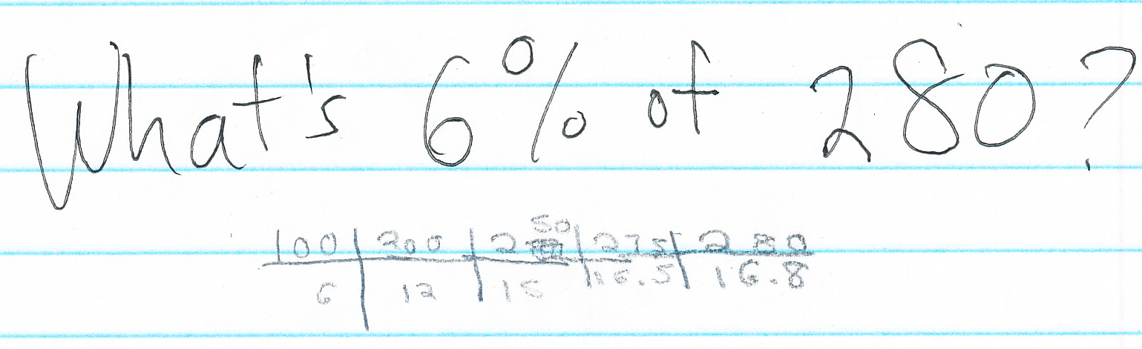
Figure 2: Sample ratio used by student to compute 6% of 280
These examples demonstrate how the ratio table approach was effective as a remedial tool and functioned as a springboard for students with stronger mathematics backgrounds toward more sophisticated strategies.

Development of Critical Thinking About Pawnshops
Critical thinking with mathematics about pawnshops can refer to the phenomenon at increasing levels of complexity (see Figure 3). At the scale of individual transactions, it is possible to use mathematics to analyze a transaction in terms of its high interest rates compared to other loans, or the way that its appraisal system might undervalue items from the perspective of the borrower. Dominant perspectives might dictate that pawnshops are legal enterprises, with published interest rates and, like any business, need to make sufficient profit.
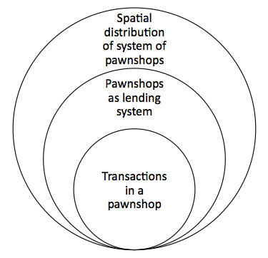
Figure 3: Levels of complexity for thinking about pawnshops

Beyond individual transactions, pawnshops can be considered as a system within the financial landscape. A critical perspective might examine that system as one that, by virtue of its extremely high rates relative to other options and the quick access it provides to small loans, is a system that preys on low-income people. A dominant perspective is that pawnshops form one choice among many options and are a financial resource for those who have poor credit or need small sums quickly.
A spatial perspective on pawnshops considers distribution across places. Patterns in that spatial distribution of mainstream and alternative financial institutions might provide evidence to suggest that the AFIs target geographical neighborhoods that have more unemployed people, immigrants, or low-income families. A dominant perspective about the spatial distribution is that pawnshops, with banks, are located in heavy shopping areas.
On the first day with the module, students were asked to name associations with pawnshops, and the teacher penned contributions on a word wall. Forty-nine words or phrases were named; 34 were related to the pawnshop transaction, with most referring to the appraisal process (25). Students less frequently (12) offered associations that might be indicative of critical perspectives about pawnshops as a lending system, with statements like “advantage,” “power,” and “they get over on you.” One comment hinted at a spatial, critical perspective: “the ‘hood.”
At the end of the module, in a whole-class discussion organized to elicit student opinions, students made 30 references to pawnshops. These 31 references (made by 8 students) mostly (20) were oriented toward pawnshops as a lending system, though some (8) referred to aspects of individual transactions, and few (3) referred to the spatial distribution. This demonstrates greater sophistication in the students’ thinking about pawnshops; prior to the module, their references were concentrated tightly around aspects of the transaction, and by the end of the module, their references had shifted largely to focus on pawnshops as a lending system.
For example, when the class was asked to agree or disagree with the statement, “Pawnshops prey on our community by charging much higher annual interest rates than banks,” one student, Lina, disagreed, providing a dominant perspective about pawnshops as a system, explaining, “I don’t think they [pawnshops] do it intentionally, I think they just do it as a choice. Like, if you don’t have the credit then you, like, it’s their, like it’s someone’s fault if they have bad credit ‘cause it’s you’re fault if you didn’t pay all your debts or whatever… they’re helping you out by at least letting you borrow money…” Another student, Bo, disagreed, offering a critical perspective: “I only see pawnshops inside, like, poor neighborhoods. So I feel like they, like, preyin’ on the poor neighborhoods, because, like, they don’t have nothin’ so if they come, then they gonna take they money.” Bo continued, recalling examining the posted interest rates and fees inside a check-cashing store during the field research session, “since it’s so expensive, right, then like the people who can’t afford it have to, like, do that because if they really need the money then they gonna have to raise all they money and then, to get that, then they gonna be broke” (11/20/14). In that summative whole-class discussion in general, more statements had critical orientations (18) than dominant (13).
Discussions and Further Questions
Findings include student interest in and adoption of ratio models for percent calculations. For struggling students, with weak scores on standardized tests, this topic remediated a central focus of middle school mathematics. At many points in the module, students pointed out that it is important for a consumer to be savvy in terms of the individual transaction, because “pawnshops get over on you.” Students felt that understanding mathematics would help them to better navigate an appraisal or loan process. One student, Sheeda, shared in the focus group that she found learning about the mathematics to be more useful to her than she had at first expected:
But then when we started like, going more in deep into the project we was like oh that’s what they really be doing, so like we really have to have that skill of math to, you know, to, pursue… like, that. Like, if we ever went to a pawnshop. (11/25/14)
In other words, mathematics would enable a position of strength instead of weakness for students as consumers. In response to a follow-up question as to whether the mathematics they learned was new, she elaborated:
Sheeda: cuz basically we learned it, but basically we, didn’t, like pursue more into it. Like, we just like, oh that’s something that we learned in school, like, we-we like…
Lina: to learn it, just to learn it…
Sheeda: Yeah, it felt like, we felt like…
Lina: ...we did, applied learning.
Sheeda: yeah, it felt like — exactly, that’s like what I was saying — like, it felt like we really needed to, like, pursue it.”
These two students made the point here that the context was not only motivating for them, but that learning this mathematics felt necessary.
By the end of the module, students expressed points of view that demonstrated that the module had opened up space for thinking more broadly than about individual transactions in pawnshops. Those points of view became more critical in orientation, and it is our interpretation that that students' learning how pawnshops work, an element of which is how to use percents to calculate interest, was a key factor in this growth. Although the module included a focus on using maps and data to make spatial arguments, such arguments were rarely assimilated into students’ opinions. An interpretation of this finding is that the students’ map and data analysis was done individually or in pairs at laptops computers, without time for interpreting or layering those observations in whole-class discussions. Collectively building understanding in whole-class discussion competed for time with individual investigations that focus on single-user technologies.
This investigation of pawnshops used mathematics of percent in different ways. This paper has a central focus of understanding how to use percent as a function and as a proportion to model a pawnshop loan and to compare loans. Yet percent was used in other parts of the module to represent demographic data as a statistic. Using percent as a function to model loan interest typically scales up from $100, while using percent as a statistic typically scales down to 100 people. Future research could focus on relationships between conceptual understanding of percent as a function, proportion, and statistic, in mathematical investigations that draw on data that pertain to demographics and place.

Acknowledgments
The research described in this paper is supported by the National Science Foundation under Grant No. DRL-1222430. Any opinions, findings, and conclusions or recommendations expressed in this material are those of the authors and do not necessarily reflect the views of the National Science Foundation. This project is conducted in collaboration with MIT’s Civic Data Design Lab and teachers from the New York City Department of Education.
References
Apple, M. W. (1992). Do the Standards go far enough? Power, policy, and practice in mathematics education. Journal for Research in Mathematics Education, 23, 412- 431.
Carpenter, T. P. & Lehrer, R. (1999). Teaching and learning mathematics with understanding. In E. Fennema & T. A. Romberg (Eds.), Classrooms that promote mathematical understanding (pp. 19-32). Mahwah, NJ: Erlbaum.
Dole, S. (2000). Promoting percent as a proportion in 8th grade mathematics. School Science and Mathematics, 100(7), 380-389.
Ginsburg, L., Gal, I. & Schuh, A. (1995) What does 100% juice mean? Exploring adult learners’ informal knowledge of percent. Retrieved from National Center on Adult Literacy.
Gruenewald, D. (2003). Foundations of place: a multi-disciplinary framework for place-conscious education. American Educational Research Journal, 40(3), 619-654.
Gutstein, E. (2005). Reading and writing the world with mathematics. New York: Routledge.
Gutstein, E., Lipman, P., Hernandez, P., & de los Reyes, R. (1997). Culturally relevant mathematics teaching in a Mexican American context. Journal for Research in Mathematics Education, 28, 709-737.
Haubner, M.A., Percent: developing meaning through models. Arithmetic Teacher, 40(4), 48-49.
Kitchen, R., Depree, J., Celedon-Pattichis, S., & Brinkerhoff, J. (2006). Mathematics education at highly effective schools that serve the poor: strategies for change. New York: Routledge.
Ladson-Billings, G. (1994). The dreamkeepers: Successful teachers of African-American children. San Francisco, CA: Jossey-Bass.
Lembke, L., & Reys, B. (1994). The development and interaction between, intuitive and school-taught ideas about percent. Journal for Research in Mathematics Education, 25(3), 237-259.
Lo, J. & Ko, Y. (2013). A bargain price for teaching about percentage. Mathematics Teaching in the Middle School, 19(2),
Middleton J. & Van den Heuvel-Panhuizen, M. (1995) The ratio table. Mathematics Teaching in the Middle School, 1(4), 282-288.
Moll, L., Amanti, C., Neff, D., & Gonzalez. N. (1992). Funds of knowledge for teaching: Using a qualitative approach to connect homes and classrooms. Theory Into Practice, 31(2), 132-141.
Moss, J. & Case, R. (1999). Developing children's understanding of the rational numbers: a new model and an experimental curriculum. Journal for Research in Mathematics Education, 30(2), 122-147.
Parker, M., & Leinhardt, G. (1995). Percent: A privileged proportion. Review of Educational Research, 65, 421-481.
Rubel, L. & Chu, H. (2012). Reinscribing urban: teaching mathematics in low-income communities of color. Journal of Mathematics Teacher Education, 15, 39-52.
Wiebe, J. Manipulating percentages. Mathematics Teacher, 79, 23-26.

